|  |  |  |  |  |  |
| --- | --- | --- | --- | --- | --- |
|  | A-C | B-C | D-H | E-G | D |
| 500Hz | 0.4756 | 0.3099 | 1.4607 | 0.1052 | 0.5363 |
| 1000Hz | 0.4560 | 0.3107 | 1.2895 | 0.1059 | 0.6581 |
| 2000Hz | 0.4959 | 0.3122 | 1.4533 | 0.1060 | 0.5449 |
| 4000Hz | 0.4431 | 0.3109 | 1.2348 | 0.1060 | 0.7167 |

**500Hz Signal**

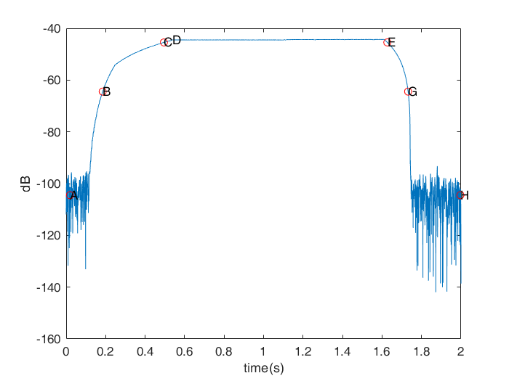

**1000Hz Signal**

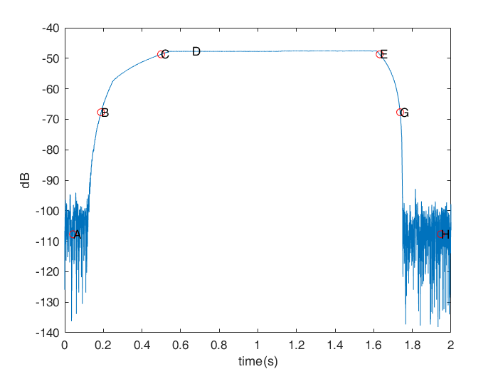

**2000Hz Signal**

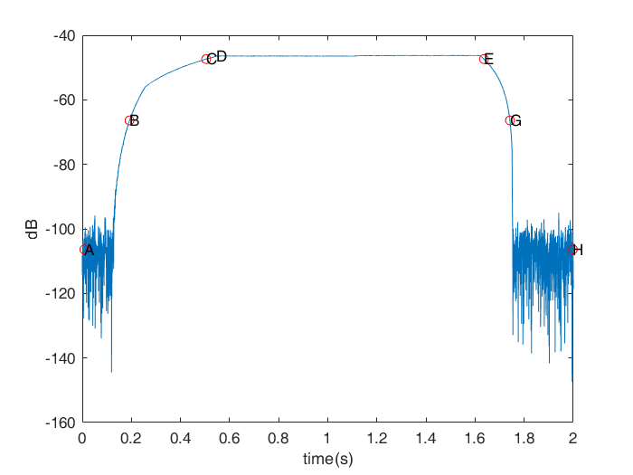

**4000Hz Signal**

